**Write an assembly language program to find factorial of n in the given number.**

**EXP NO: 18**

**AIM:** To find the factorial of a given number using 8085 microproccessor.

**ALGORITHM:**

1. Load the data into register B
2. To start multiplication set D to 01H
3. Jump to step 7
4. Decrements B to multiply previous number
5. Jump to step 3 till value of B>0
6. Take memory pointer to next location and store result
7. Load E with contents of B and clear accumulator
8. Repeatedly add contents of D to accumulator E times
9. Store accumulator content to D
10. Go to step 4

**PROGRAM:**

LDA 2001

MOV B, A

MVI C, #01

MVI E, #01

LOOP: MOV D, C

MVI A,00H

LP: ADD E

DCR D

JNZ LP

MOV E, A

INR C

DCR B

JNZ LOOP

MOV A, E

STA 2010

HLT

**INPUT:**

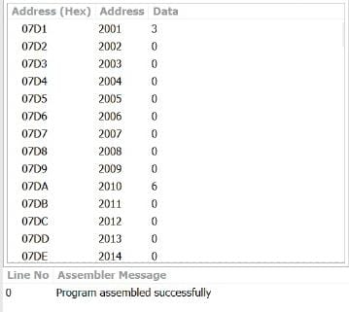

**OUTPUT:**

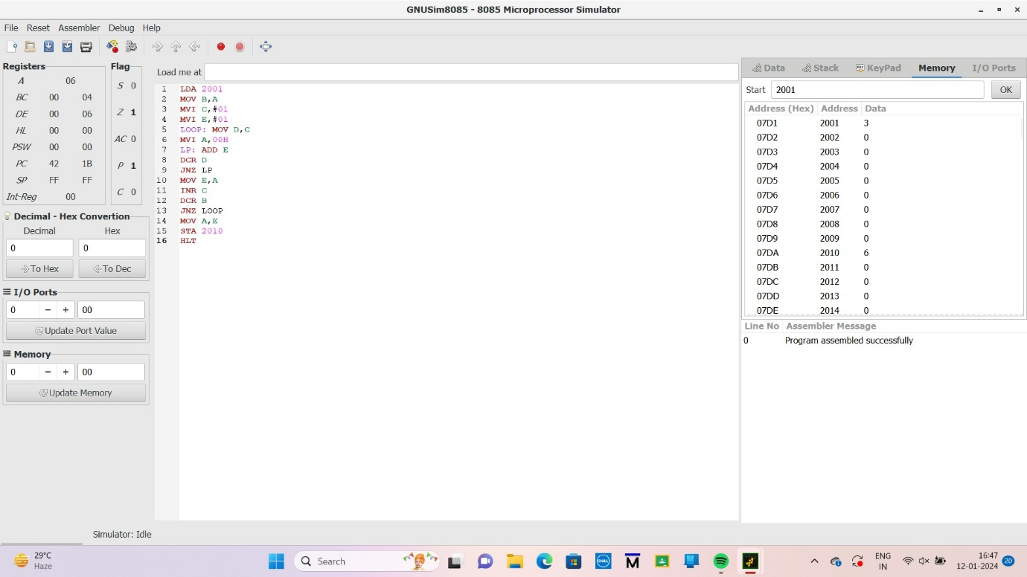

**RESULT:** Thus the program was executed successfully using 8085 processor simulator.